Lab Report

Your Information
Your Name: Joshua Zimmerman-Gibson
Assignment Title: Create Visualizations in Tableau

Screenshots
Step 1.2: Add a Personalized StudentID Field
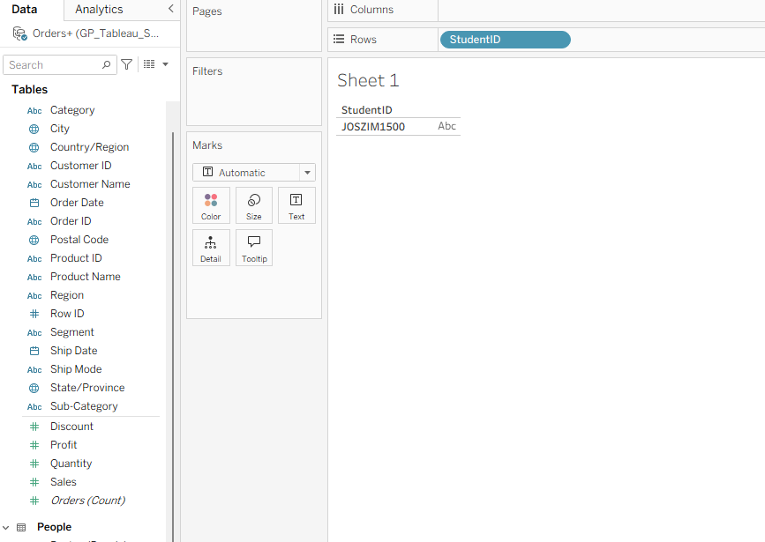
Step 2.1: Line Chart for Sales Trends
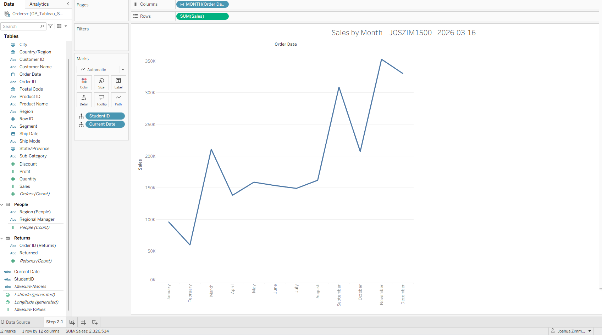
Step 2.2: Geographic Plot for Regional Analysis
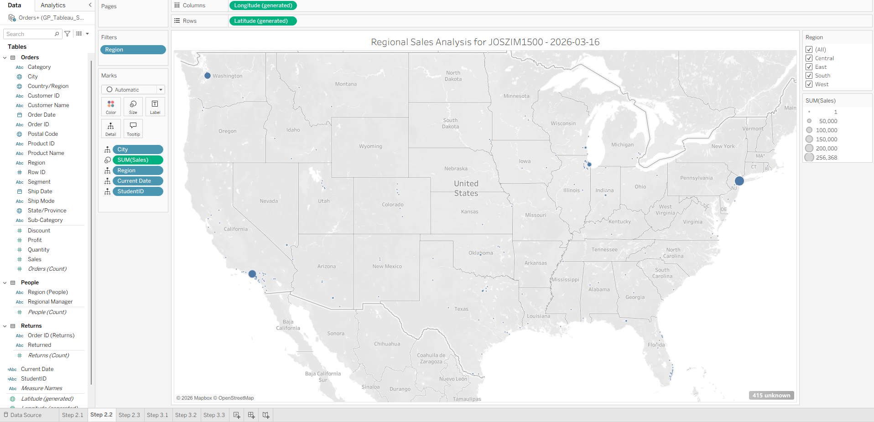
Step 2.3: Bar Char for Customer Segment Analysis
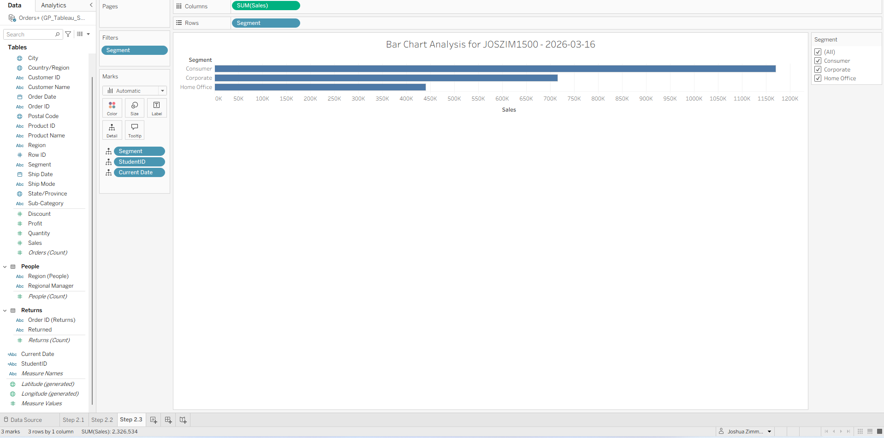
Step 3.1: Dual-Axis Chart for Sales vs Profit.
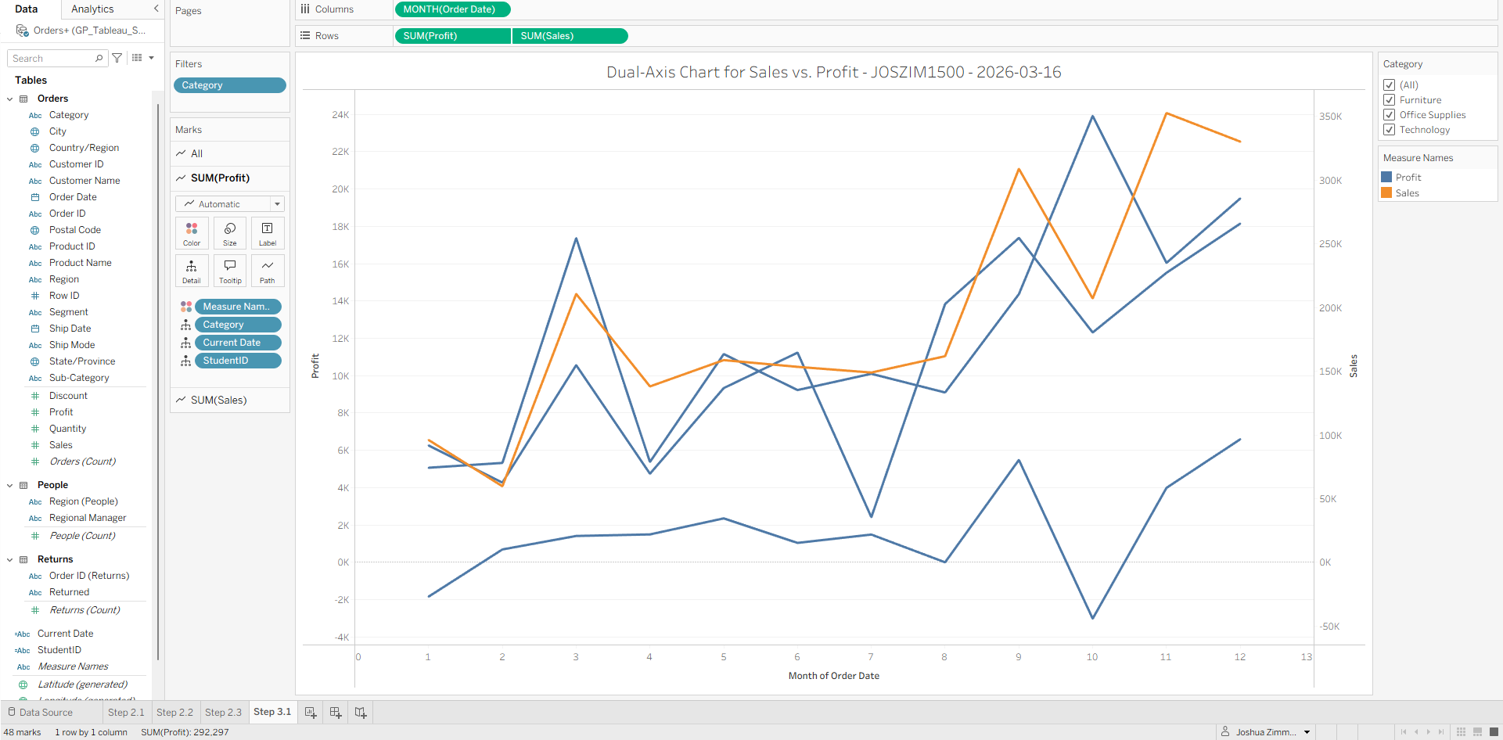
Step 3.2: Heat Map for Product Category Performance
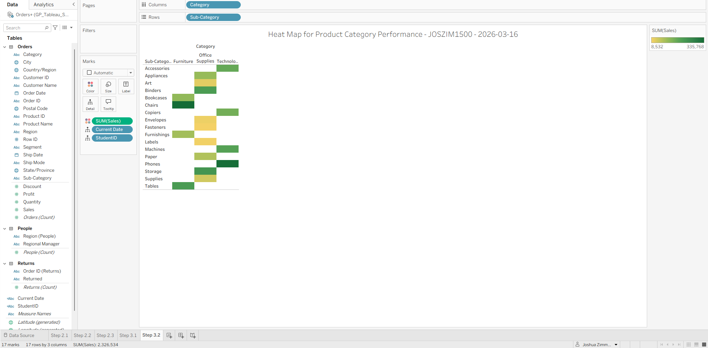
Step 3.3: Box-and-Whisker Plot for Sales Distribution by Segment
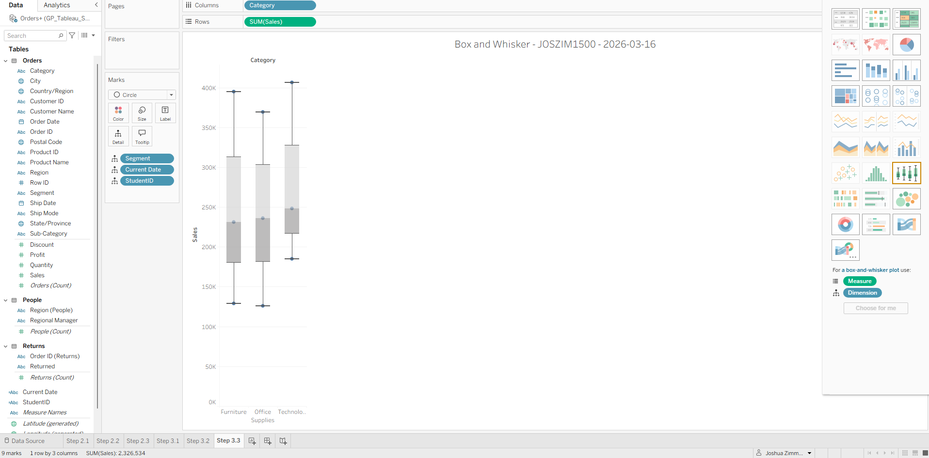

Questions
- How does a box and whisker plot display the central tendency and variability of a dataset?
A box-and-whisker plot (also called a box plot) visually summarizes how data is spread out. It shows:
- Median (central tendency):
The line inside the box marks the median, which is the middle value of the dataset.
- Interquartile Range (IQR variability):
The box represents the middle 50% of the data (from the 25th percentile to the 75th percentile).
A wider box = more variability.
A narrow box = less variability.
- Whiskers (spread):
The “whiskers” extend to show the minimum and maximum values within a calculated range.
This gives a sense of how far the data stretches.
- Outliers:
Any points outside the whiskers appear as individual marks, showing unusually high or low values.

- What is the difference between a measure and a dimension in Tableau?
Tableau separates fields into Dimensions and Measures, and understanding the difference is essential:
Dimensions
- Describe categories or qualitative data.
- Examples: Region, Product Category, Customer Name, Order Date.
- Usually used to slice, filter, or group data.
- They create headers in a view (e.g., row/column labels).
Measures
- Represent numeric, quantitative data.
- Examples: Sales, Profit, Quantity.
- Tableau usually aggregates measures (SUM, AVG, MAX, etc.).
- They create axes in visualizations (e.g., height or length of bars).
In short:
- Dimensions = categories.
- Measures = numbers being measured or aggregated.
- How can you ensure a field is treated uniquely in a view without aggregating it in Tableau?
  - Use “Measure Names” / “Measure Values” appropriately
  - Turn off aggregation
  - Make the field a Dimension
  - Use “Exact Date,” “Attribute,” or “Detail”

